WALMART SALES DATA ANALYSIS

**# FEATURE ENGINEERING**

**Calculate the time of day from time column**

SELECT Time,( CASE

WHEN 'Time' BETWEEN '00:00:00' AND '12:00:00' THEN 'Morning'

WHEN 'Time' BETWEEN '12:01:00' AND '16:00:00' THEN 'Afternoon'

ELSE 'Evening'

END )AS Time_of_day FROM Sales;

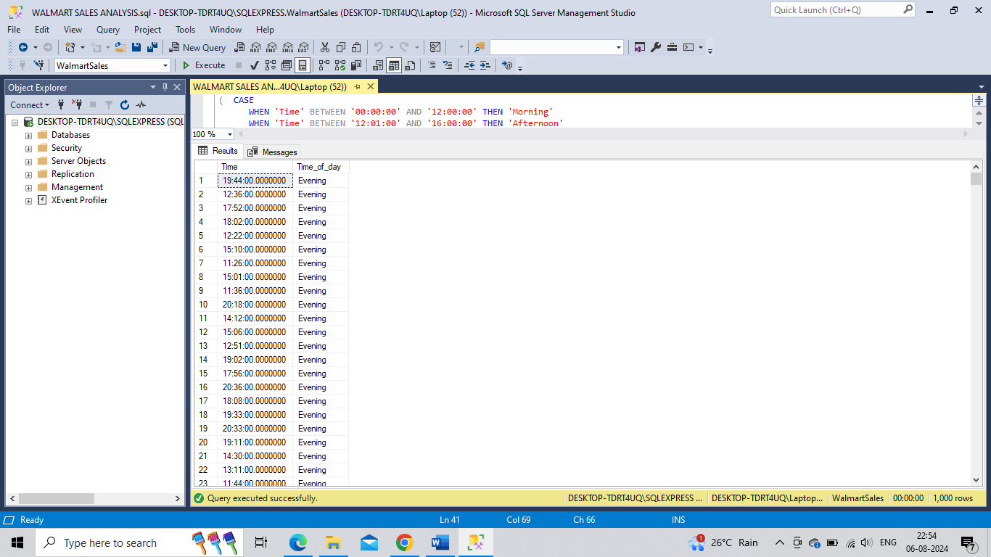

ALTER TABLE Sales ADD Time_of_day VARCHAR(20);

UPDATE Sales SET Time_of_day = (CASE

WHEN 'Time' BETWEEN '00:00:00' AND '12:00:00' THEN 'Morning'

WHEN 'Time' BETWEEN '12:01:00' AND '16:00:00' THEN 'Afternoon'

ELSE 'Evening' END );

**ADD DAY NAME COLUMN**

SELECT Date,FORMAT(Date,'dddd') from Sales;

ALTER TABLE Sales ADD Day_name VARCHAR(10);

UPDATE Sales

SET Day_name = FORMAT(Date,'dddd');

SELECT * FROM Sales;

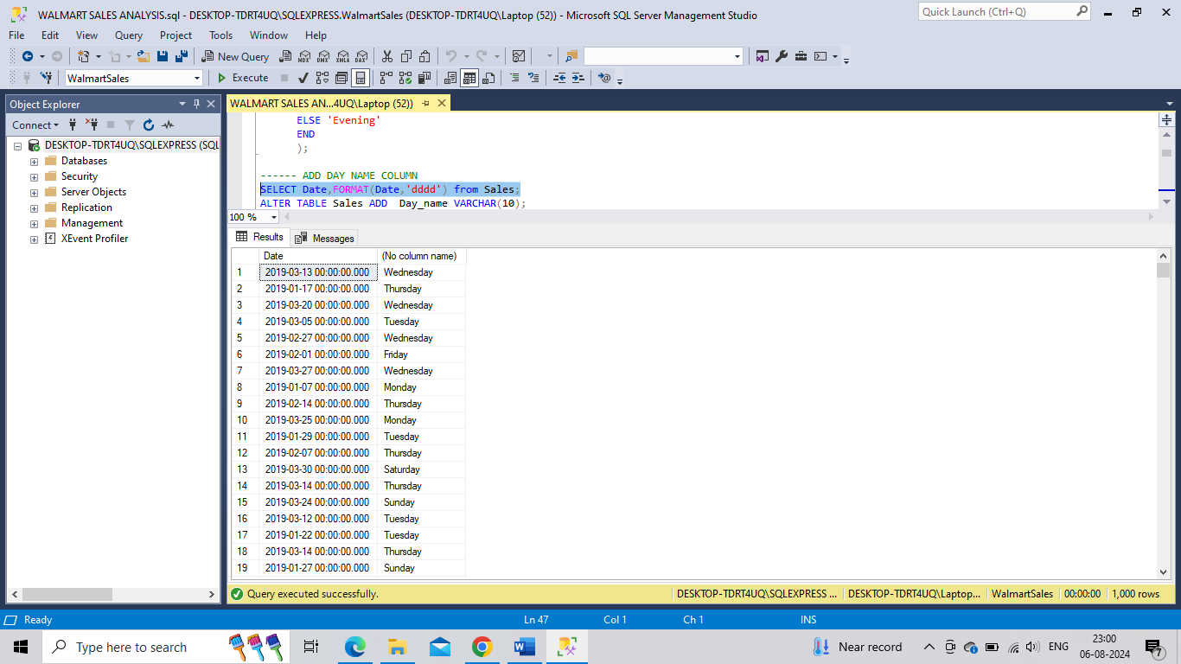

**Q.1. How many unique cities does the data have?**

SELECT DISTINCT(City) AS unique_city from Sales;

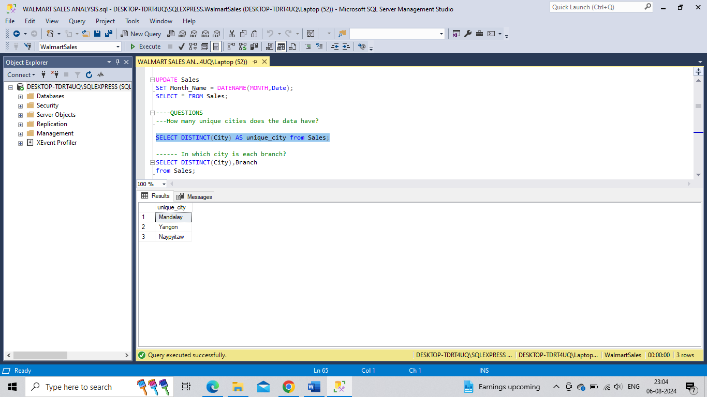

**Q.2. In which city is each branch?**

SELECT DISTINCT(City),Branch from Sales;

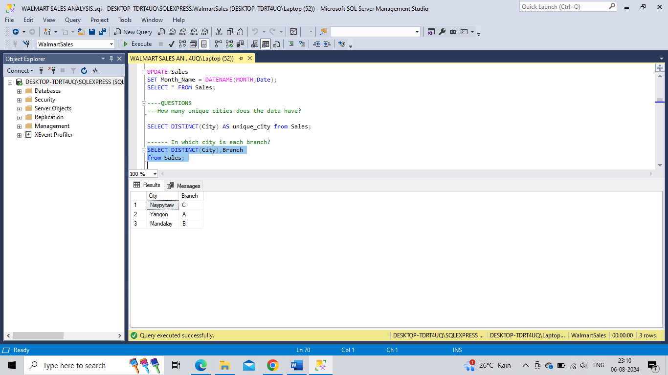

**Q.3. How many unique product lines does the data have?**

SELECT DISTINCT(Product_line) as unique_product_line from Sales;

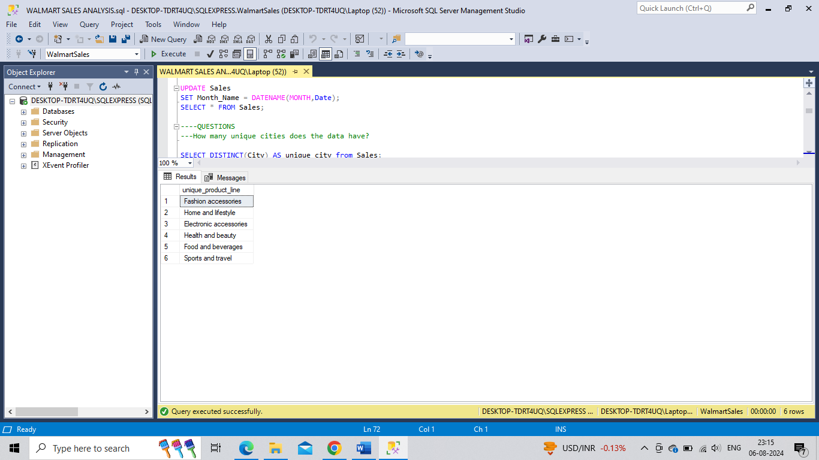

**Q.4. What is the most selling product line ?**

SELECT SUM(Quantity) as Quantity,Product_line from Sales Group by Product_line Order by SUM(Quantity) DESC;

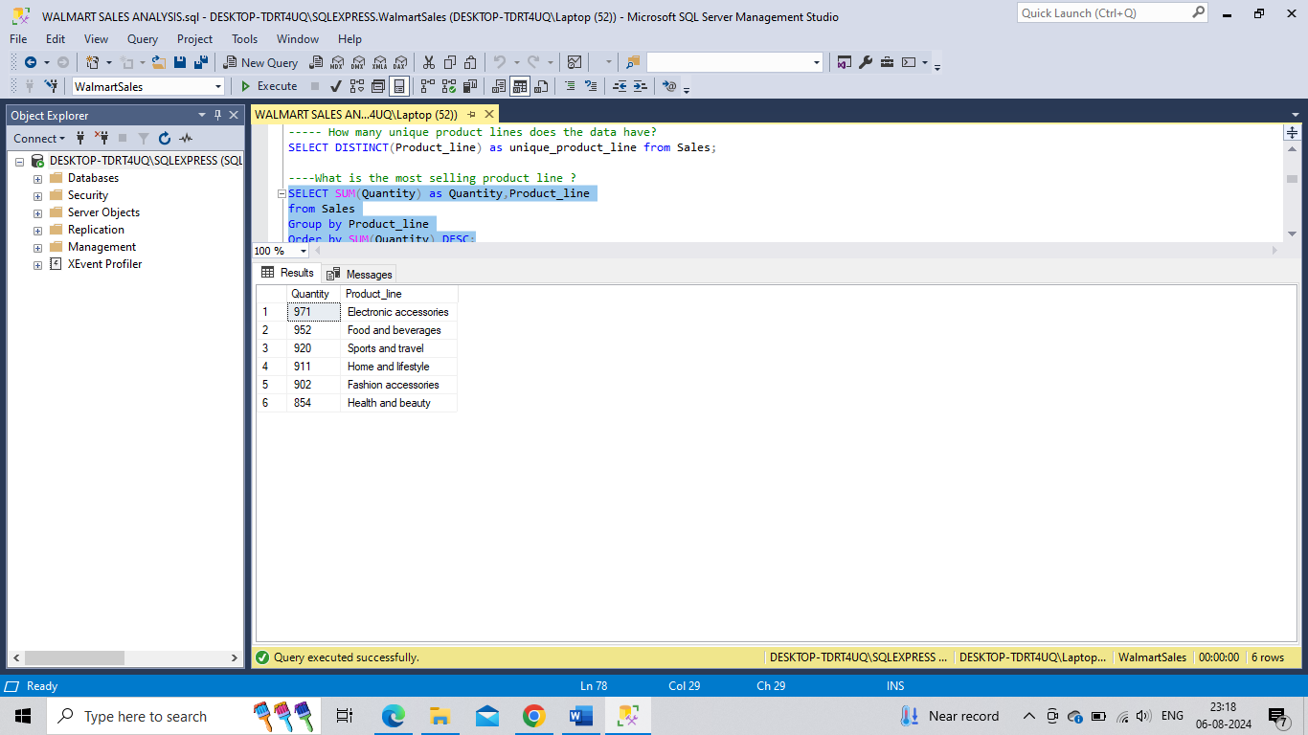

**Q.5. What is the total revenue by month ?**

SELECT Month_Name as Month, SUM(Total) AS Total_Revenue FROM SALES

GROUP BY Month_Name ORDER BY Total_Revenue desc;

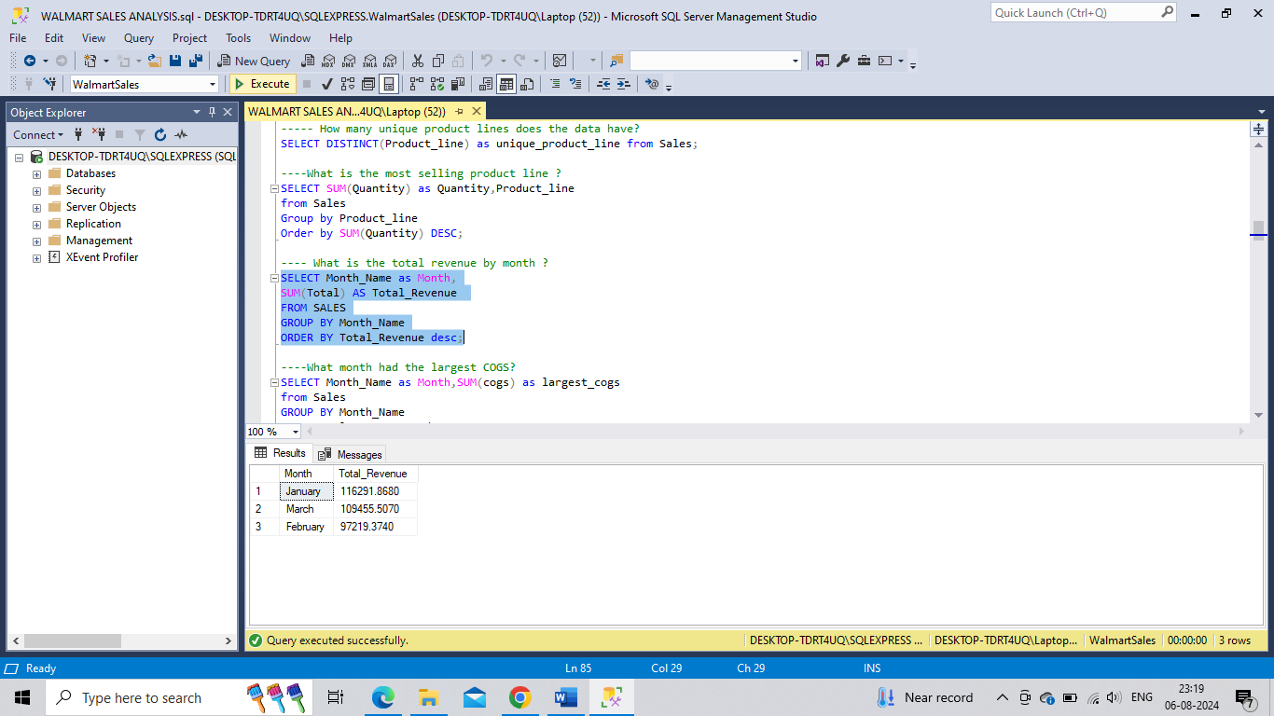

Q.6. **What month had the largest COGS?**

SELECT Month_Name as Month,SUM(cogs) as largest_cogs

from Sales

GROUP BY Month_Name

ORDER BY largest_cogs desc;

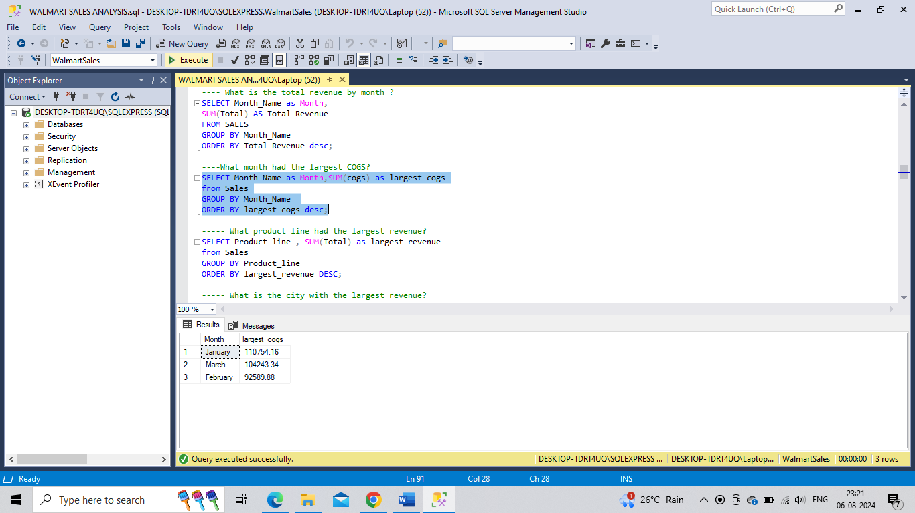

**Q.7. What product line had the largest revenue?**

SELECT Product_line , SUM(Total) as largest_revenue

from Sales

GROUP BY Product_line

ORDER BY largest_revenue DESC;

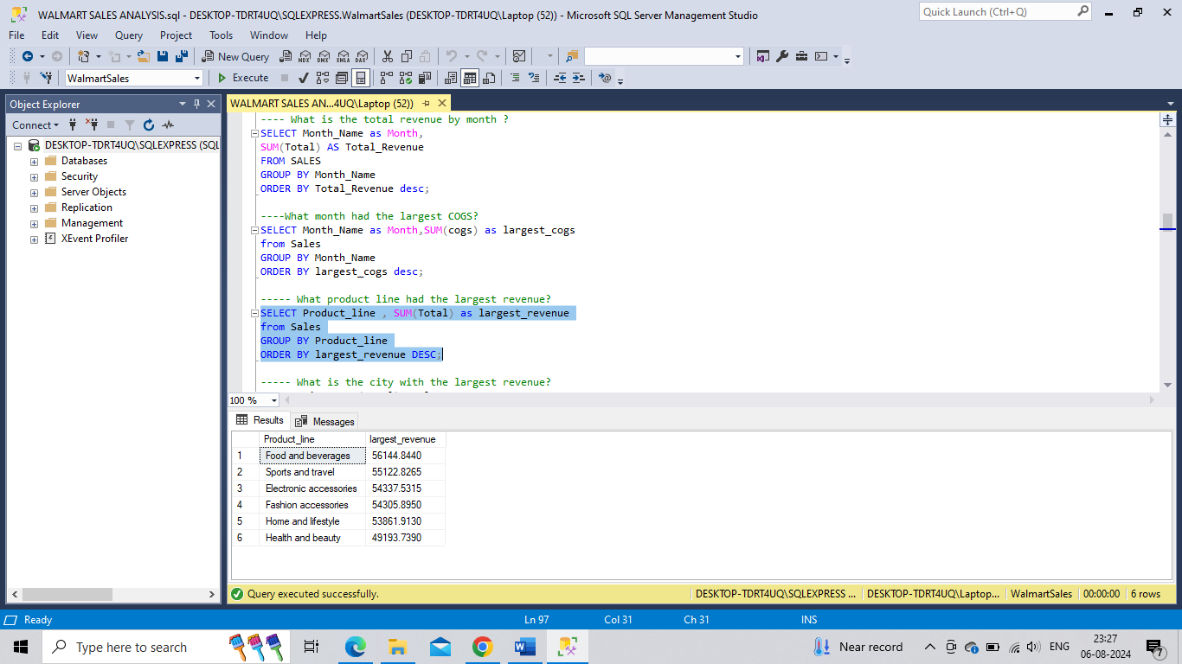

**Q.8. What is the city with the largest revenue?**

SELECT City ,SUM(Total) as largest_revenue

FROM Sales

GROUP BY City

ORDER BY largest_revenue;

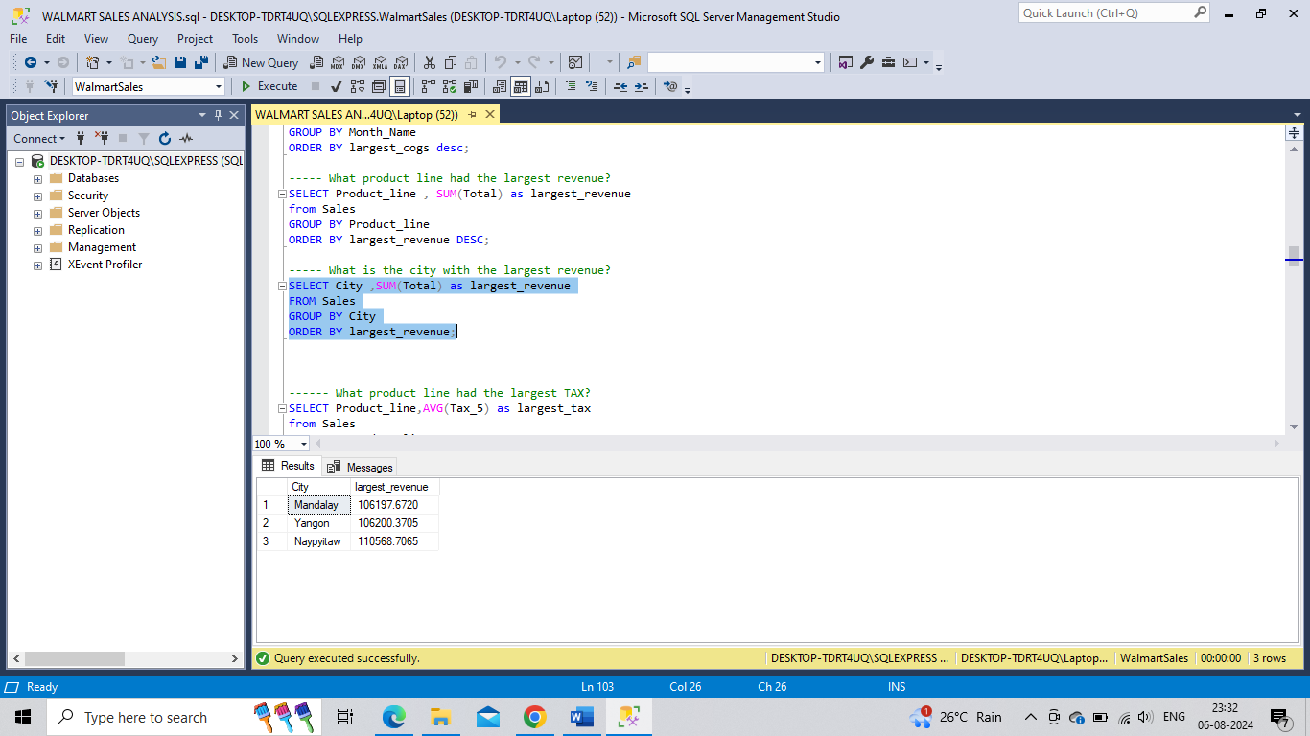

**Q.9. What product line had the largest TAX?**

SELECT Product_line,AVG(Tax_5) as largest_tax

from Sales

GROUP BY Product_line

ORDER BY largest_tax DESC;

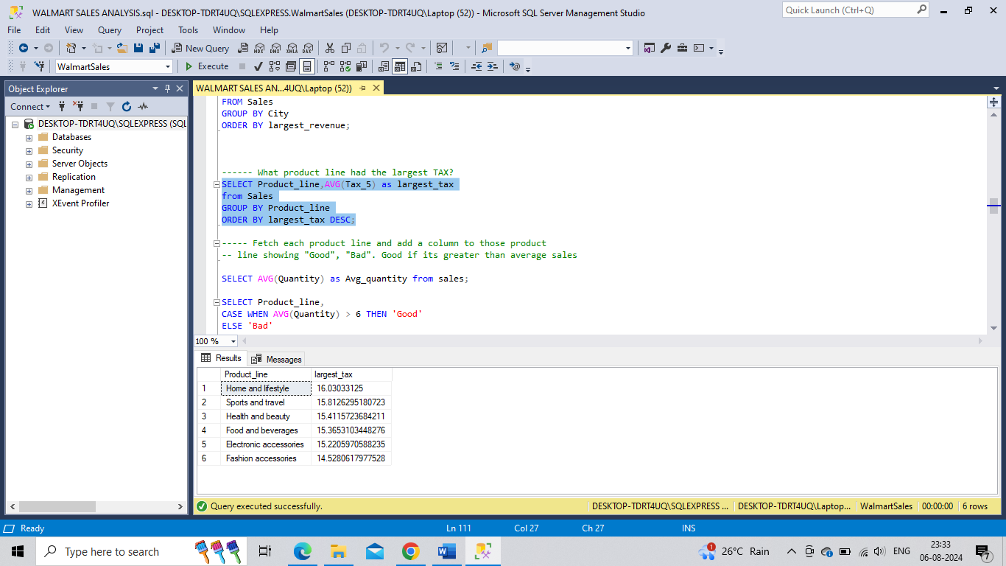

**Q.10. Fetch each product line and add a column to those product line showing "Good", "Bad". Good if its greater than average sales**

SELECT Product_line,

CASE WHEN AVG(Quantity) > 6 THEN 'Good' ELSE 'Bad'

END AS rm FROM Sales GROUP BY Product_line;

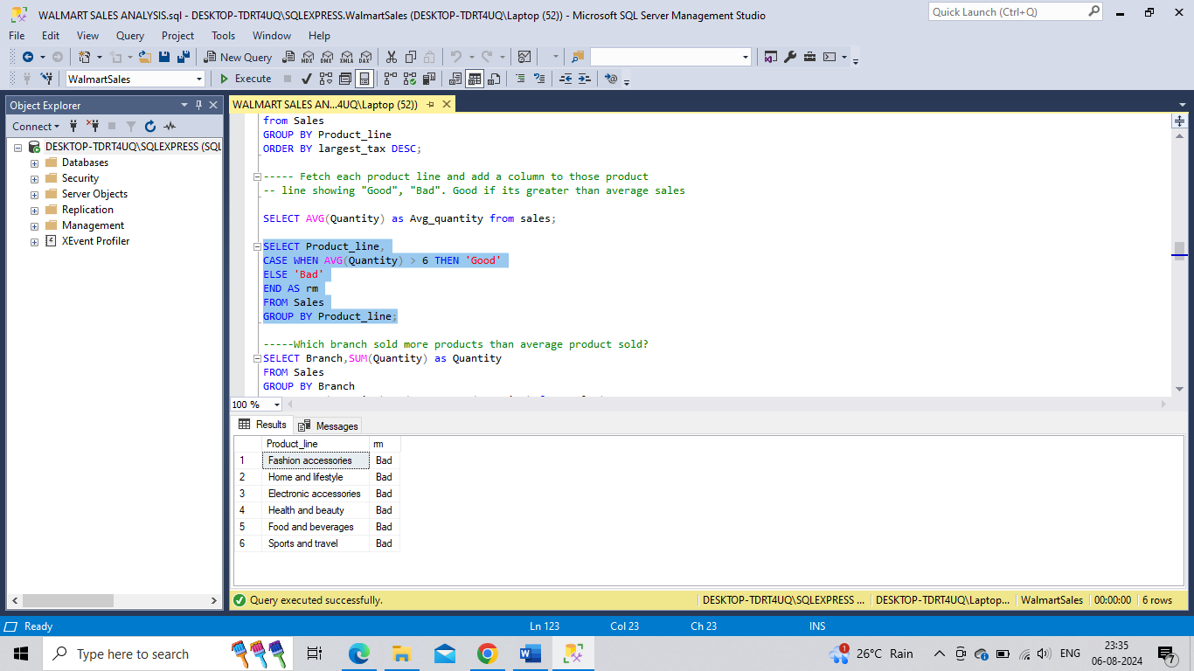

**Q.11. Which branch sold more products than average product sold?**

SELECT Branch,SUM(Quantity) as Quantity

FROM Sales

GROUP BY Branch

HAVING SUM(Quantity) > (SELECT AVG(Quantity) from Sales);

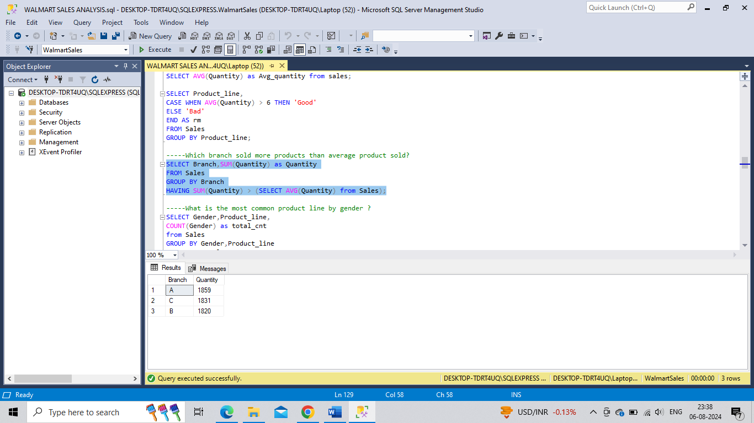

**Q.12. What is the most common product line by gender ?**

SELECT Gender,Product_line, COUNT(Gender) as total_cnt from Sales

GROUP BY Gender,Product_line ORDER BY total_cnt;

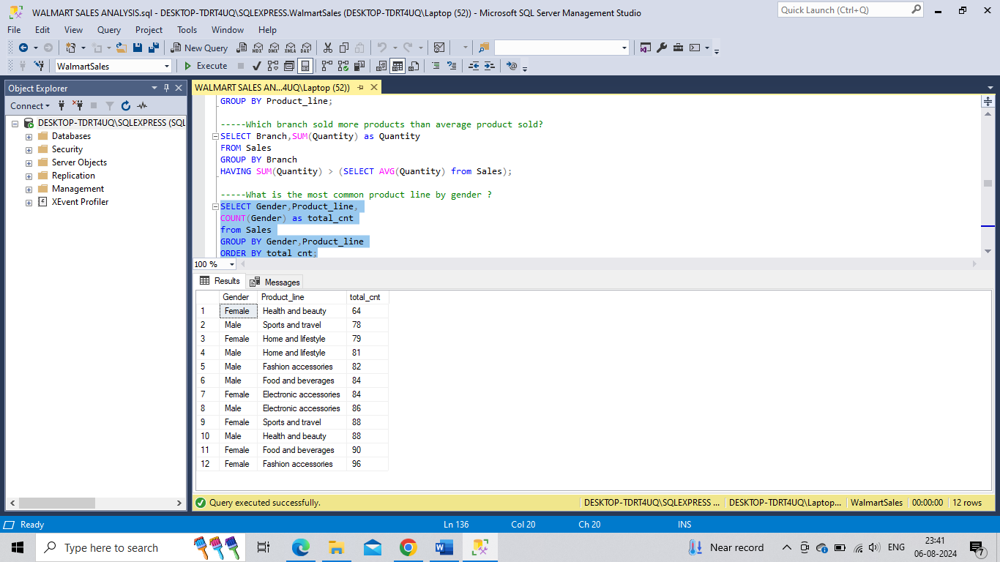

**Q.13. What is the average rating of each product line**

SELECT ROUND(AVG(Rating), 2)as avg_rating ,Product_line FROM

Sales GROUP BY Product_line ORDER BY avg_rating DESC;

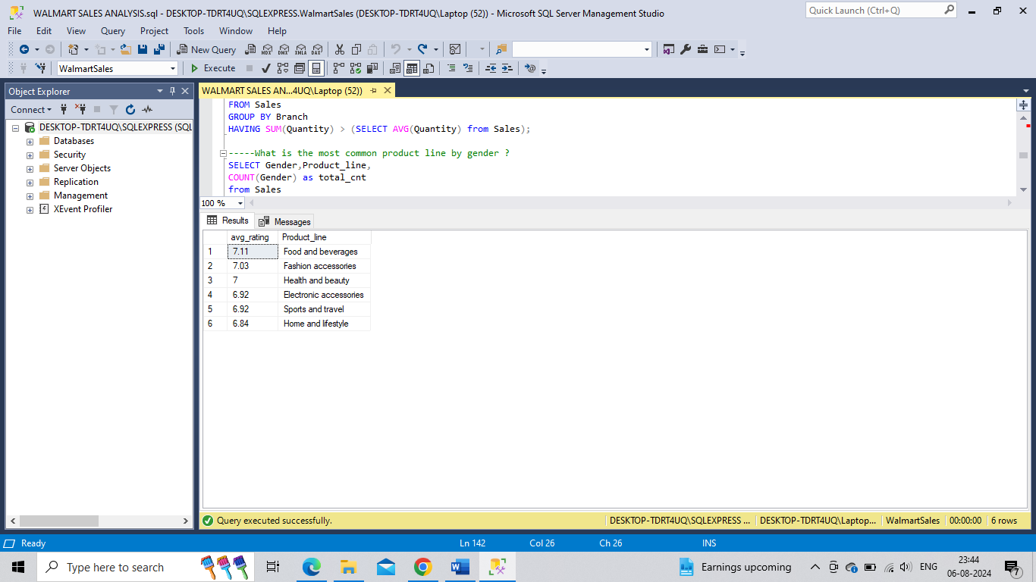

**Q.14. How many unique customer types does the data have?**

SELECT DISTINCT(Customer_type) as unique_customer_type from Sales;

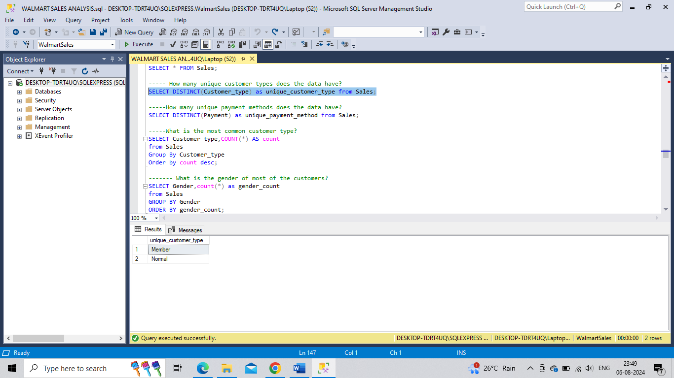

**Q.15. How many unique payment methods does the data have?**

SELECT DISTINCT(Payment) as unique_payment_method from Sales;

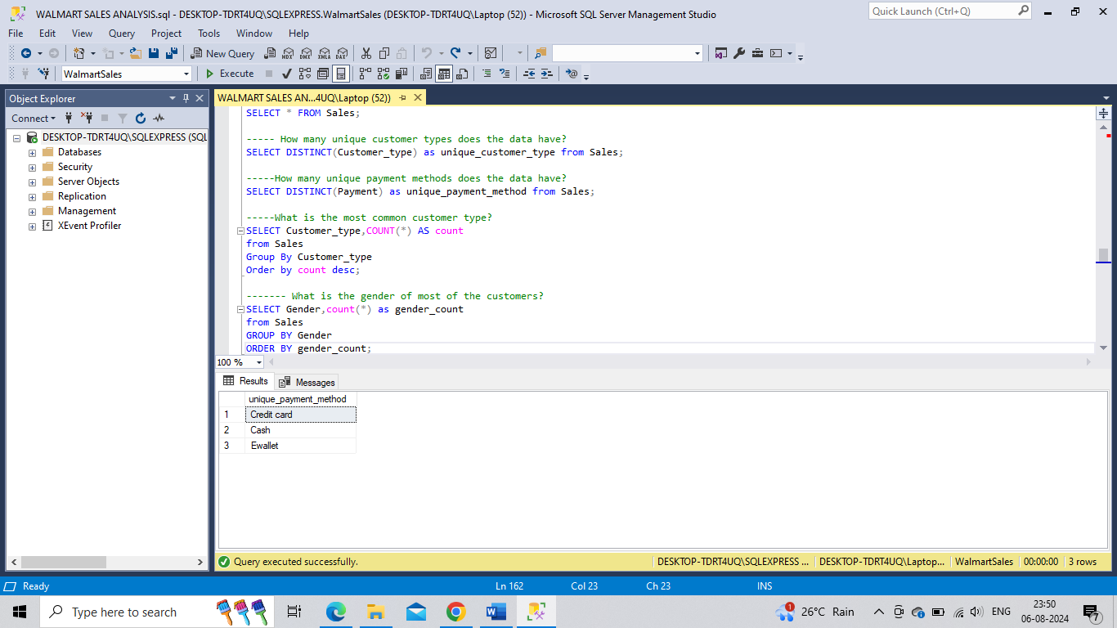

**Q.16. What is the most common customer type?**

SELECT Customer_type,COUNT(*) AS count

from Sales

Group By Customer_type Order by count desc;

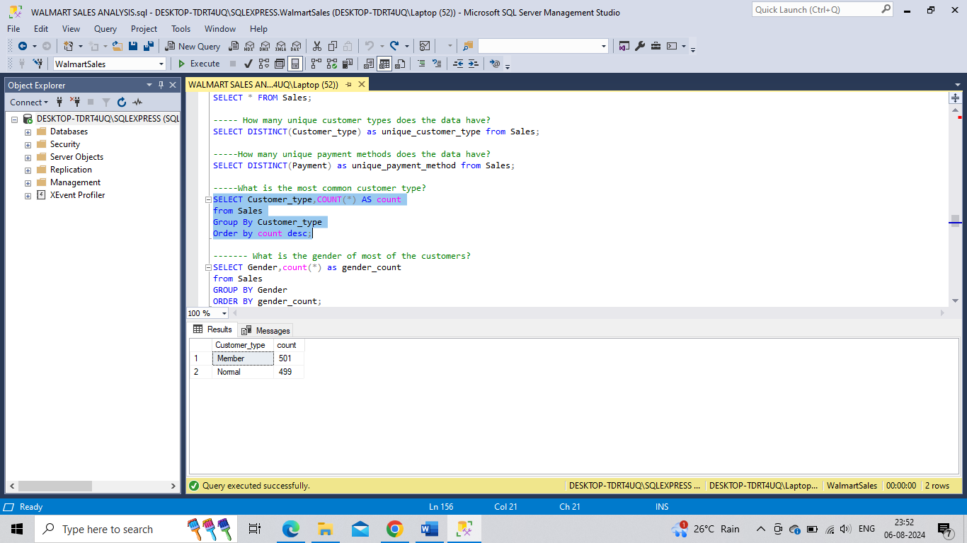

Q.17. **What is the gender of most of the customers?**

SELECT Gender,count(*) as gender_count

from Sales GROUP BY Gender ORDER BY gender_count;

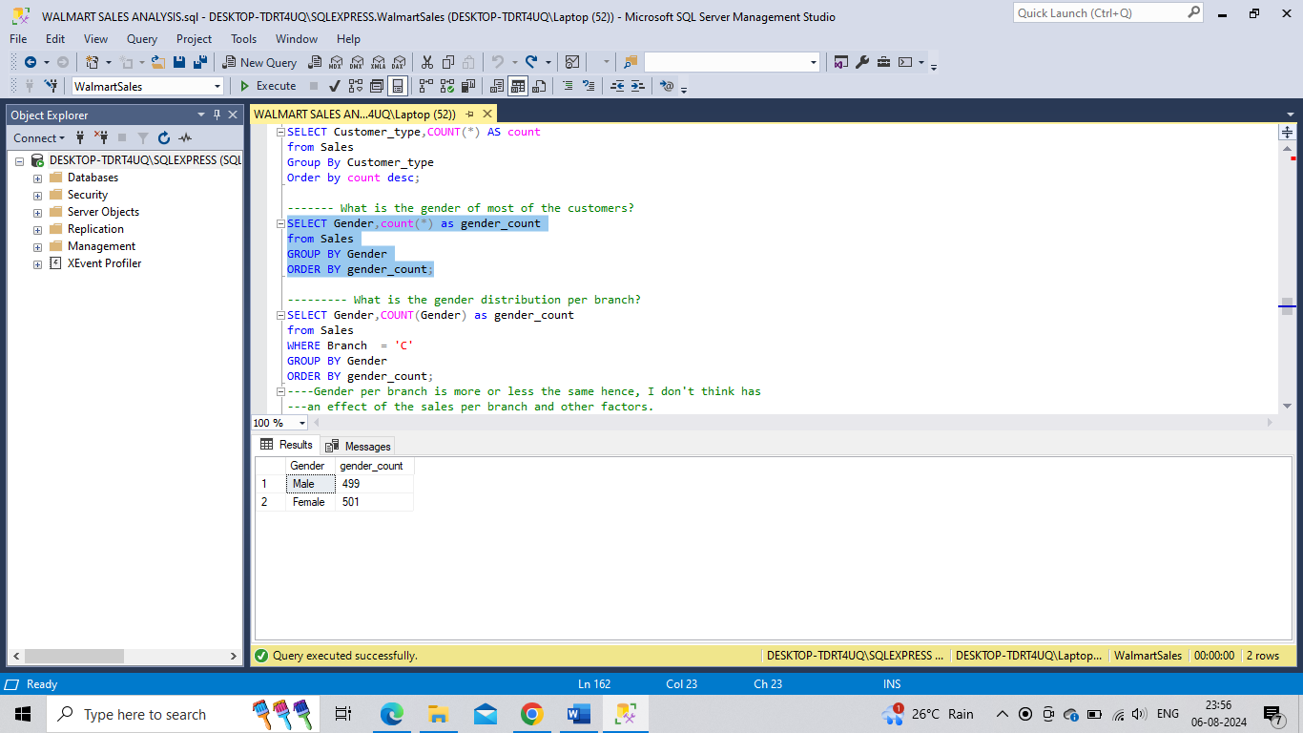

**Q.18.** **What is the gender distribution per branch?**

SELECT Gender,COUNT(Gender) as gender_count

from Sales WHERE Branch = 'C' GROUP BY Gender ORDER BY gender_count;

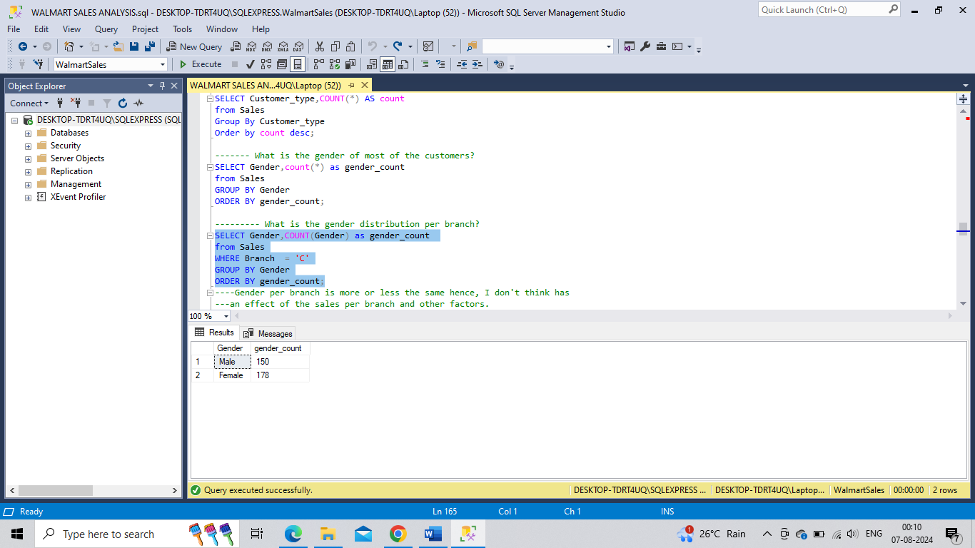

**Q.19. Which day of the week has the best avg ratings?**

SELECT Day_name,AVG(Rating) as avg_rating FROM Sales

GROUP BY Day_name ORDER BY avg_rating DESC;

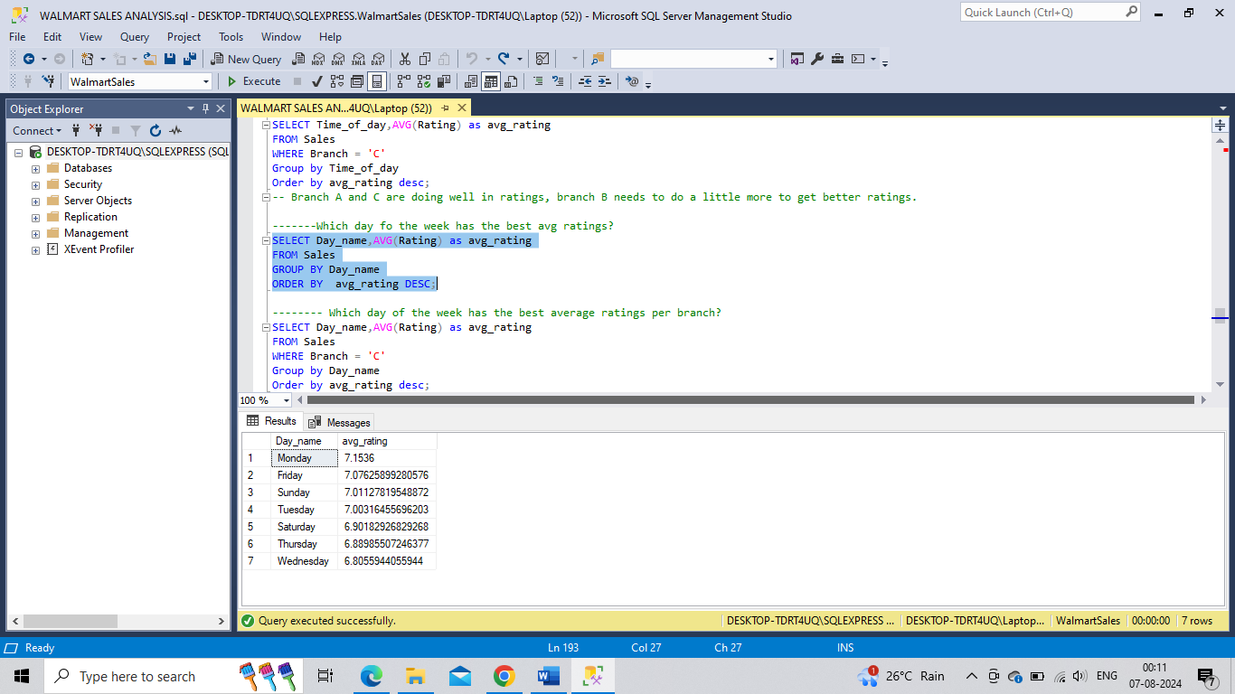

**Q.20. Which day of the week has the best average ratings per branch?**

SELECT Day_name,AVG(Rating) as avg_rating FROM Sales

WHERE Branch = 'C' Group by Day_name Order by avg_rating desc;

SELECT Day_name,AVG(Rating) as avg_rating FROM Sales WHERE Branch = 'A'

Group by Day_name Order by avg_rating desc;

SELECT Day_name,AVG(Rating) as avg_rating FROM Sales

WHERE Branch = 'B' Group by Day_name Order by avg_rating desc;

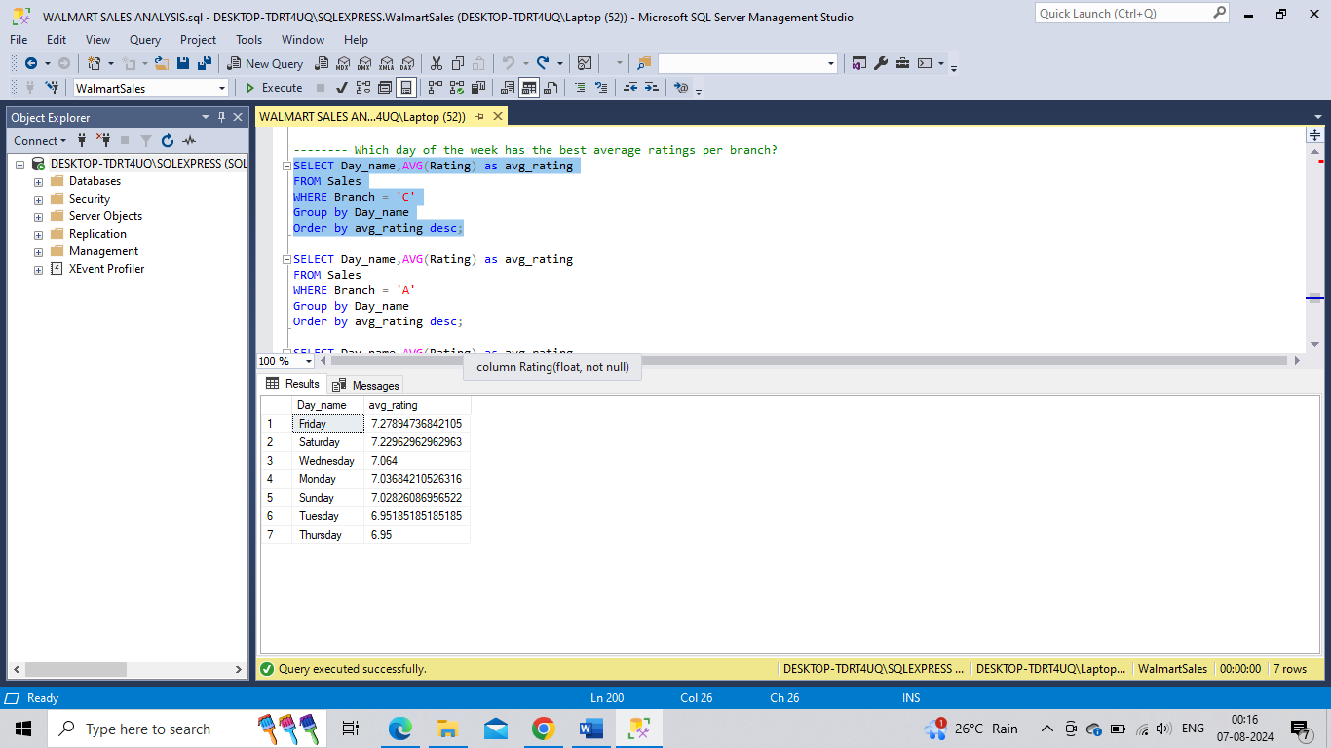

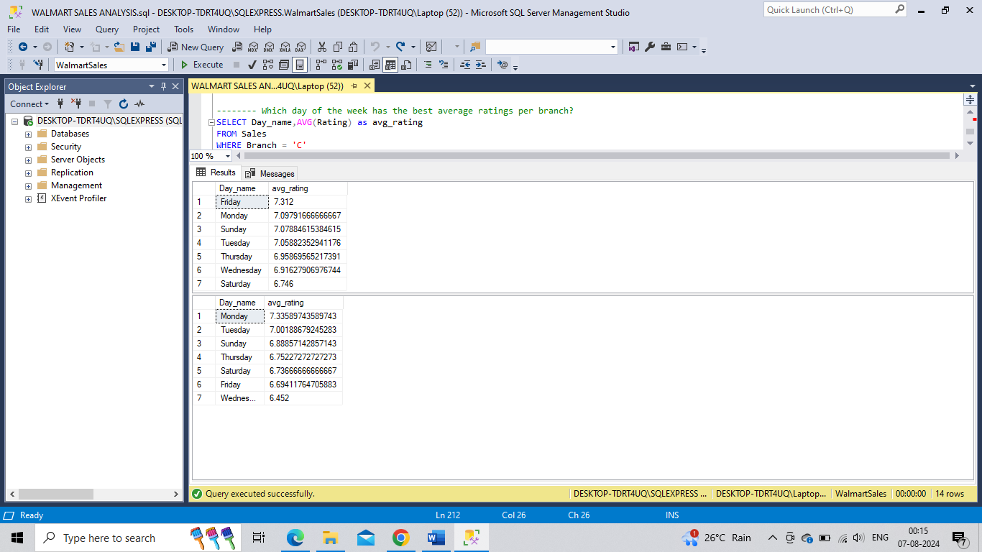

**Q.21. Number of sales made in each time of the day per weekday**

SELECT Time_of_day, COUNT(*) AS total_sales FROM Sales

WHERE Day_name = 'Monday' GROUP BY Time_of_day ORDER BY total_sales;

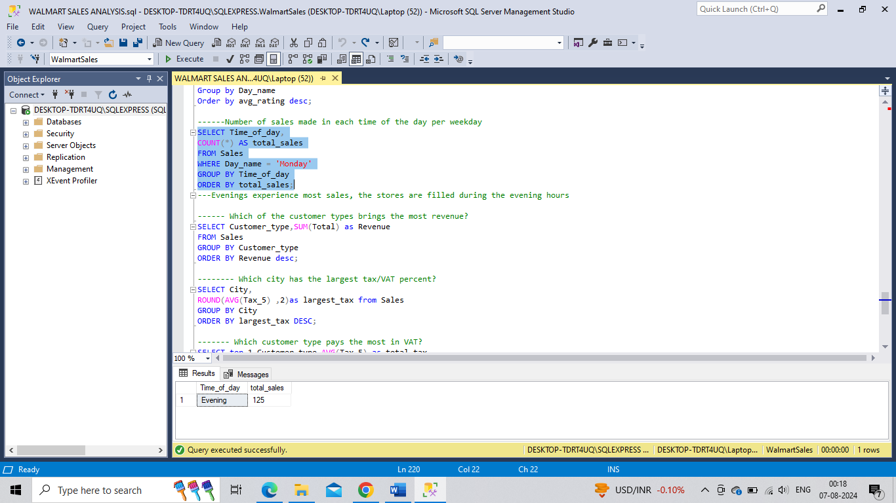

**Q.22. Which of the customer types brings the most revenue?**

SELECT Customer_type,SUM(Total) as Revenue FROM Sales

GROUP BY Customer_type ORDER BY Revenue desc;

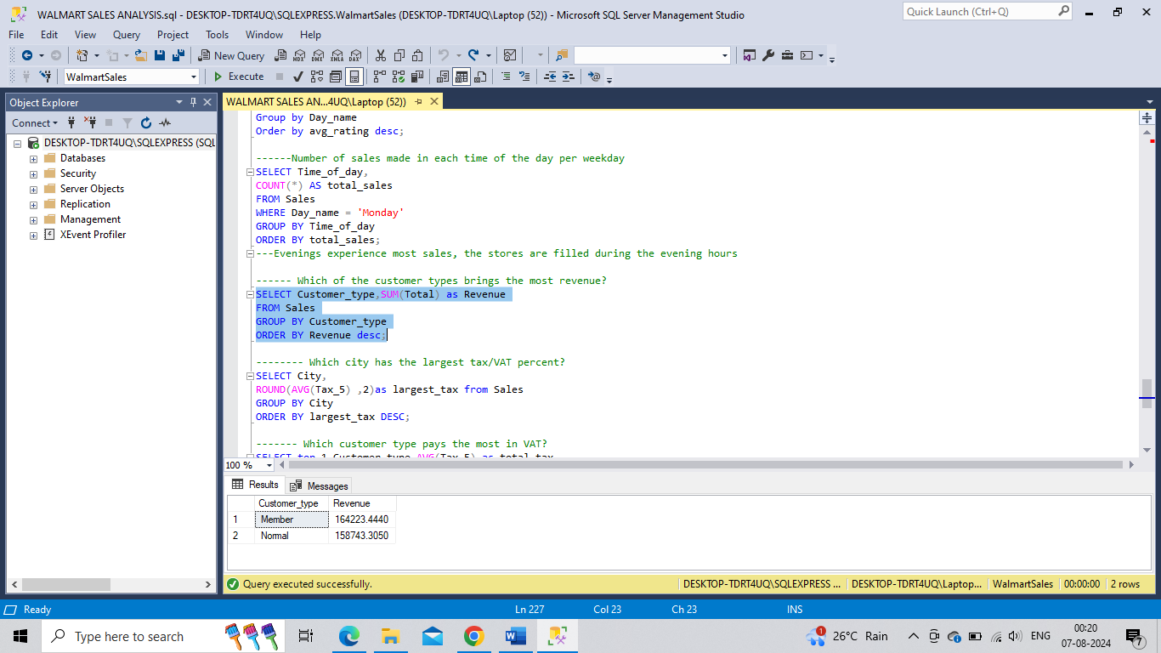

**Q.23.** **Which city has the largest tax/VAT percent?**

SELECT City, ROUND(AVG(Tax_5) ,2)as largest_tax from Sales

GROUP BY City ORDER BY largest_tax DESC;

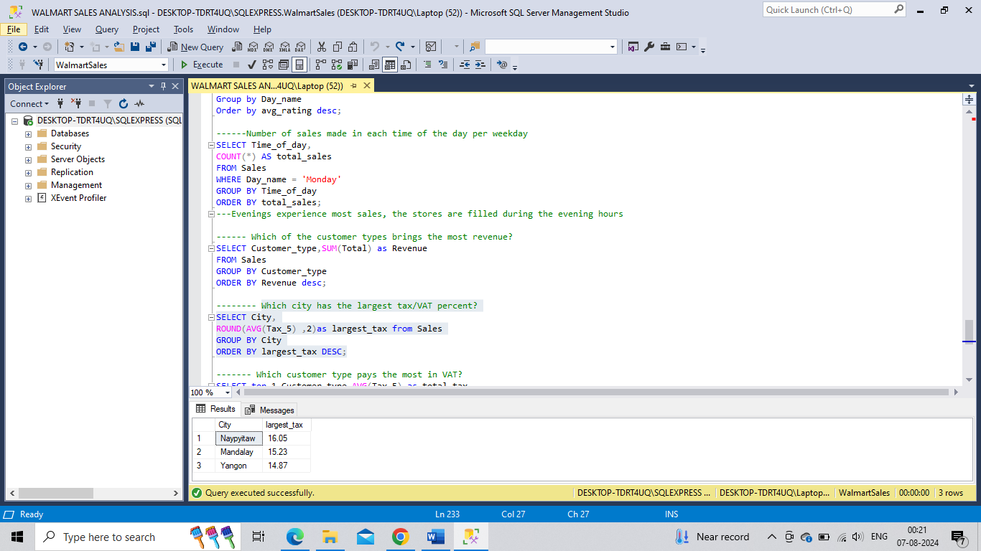

**Q.24. Which customer type pays the most in VAT?**

SELECT top 1 Customer_type,AVG(Tax_5) as total_tax

from Sales

GROUP BY Customer_type

ORDER BY total_tax desc;

